**Project 2 Milestone1**

**Description:** I aim to build an reminder app helping users manage their life better by setting and finishing basic daily tasks on time. The inspiration of this app came from my observation that many people, especially people have mental health problems tend not to handle their daily life well. They need a tool to remind them of some activities when they are not in good mental condition.

**Audience:** Aimed at but not limited at people with bipolar disorder. This app will help users live a regular and healthy life by allowing them to finish basic daily stuffs on time.

**Research:** Research shows that similar apps in market are either focusing on the pure text to-do list function or just a questionnaire testing whether someone has mental health problem. My app will have an appealing watercolor UI and be embed with a plant-growing system to visualize the status of users.

**Resources:** I am responsible for the design and reminder part development.

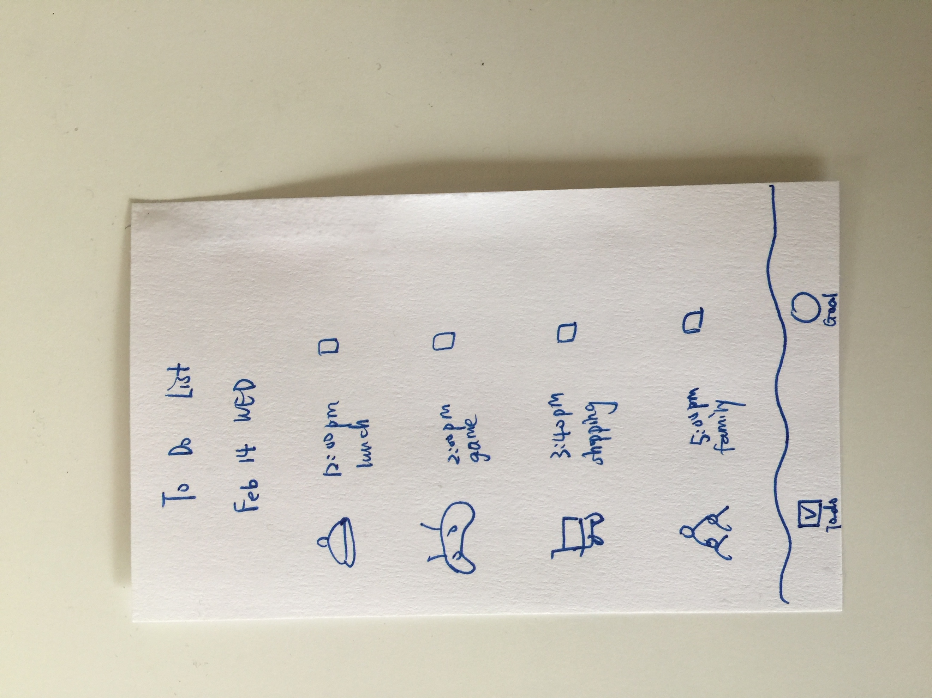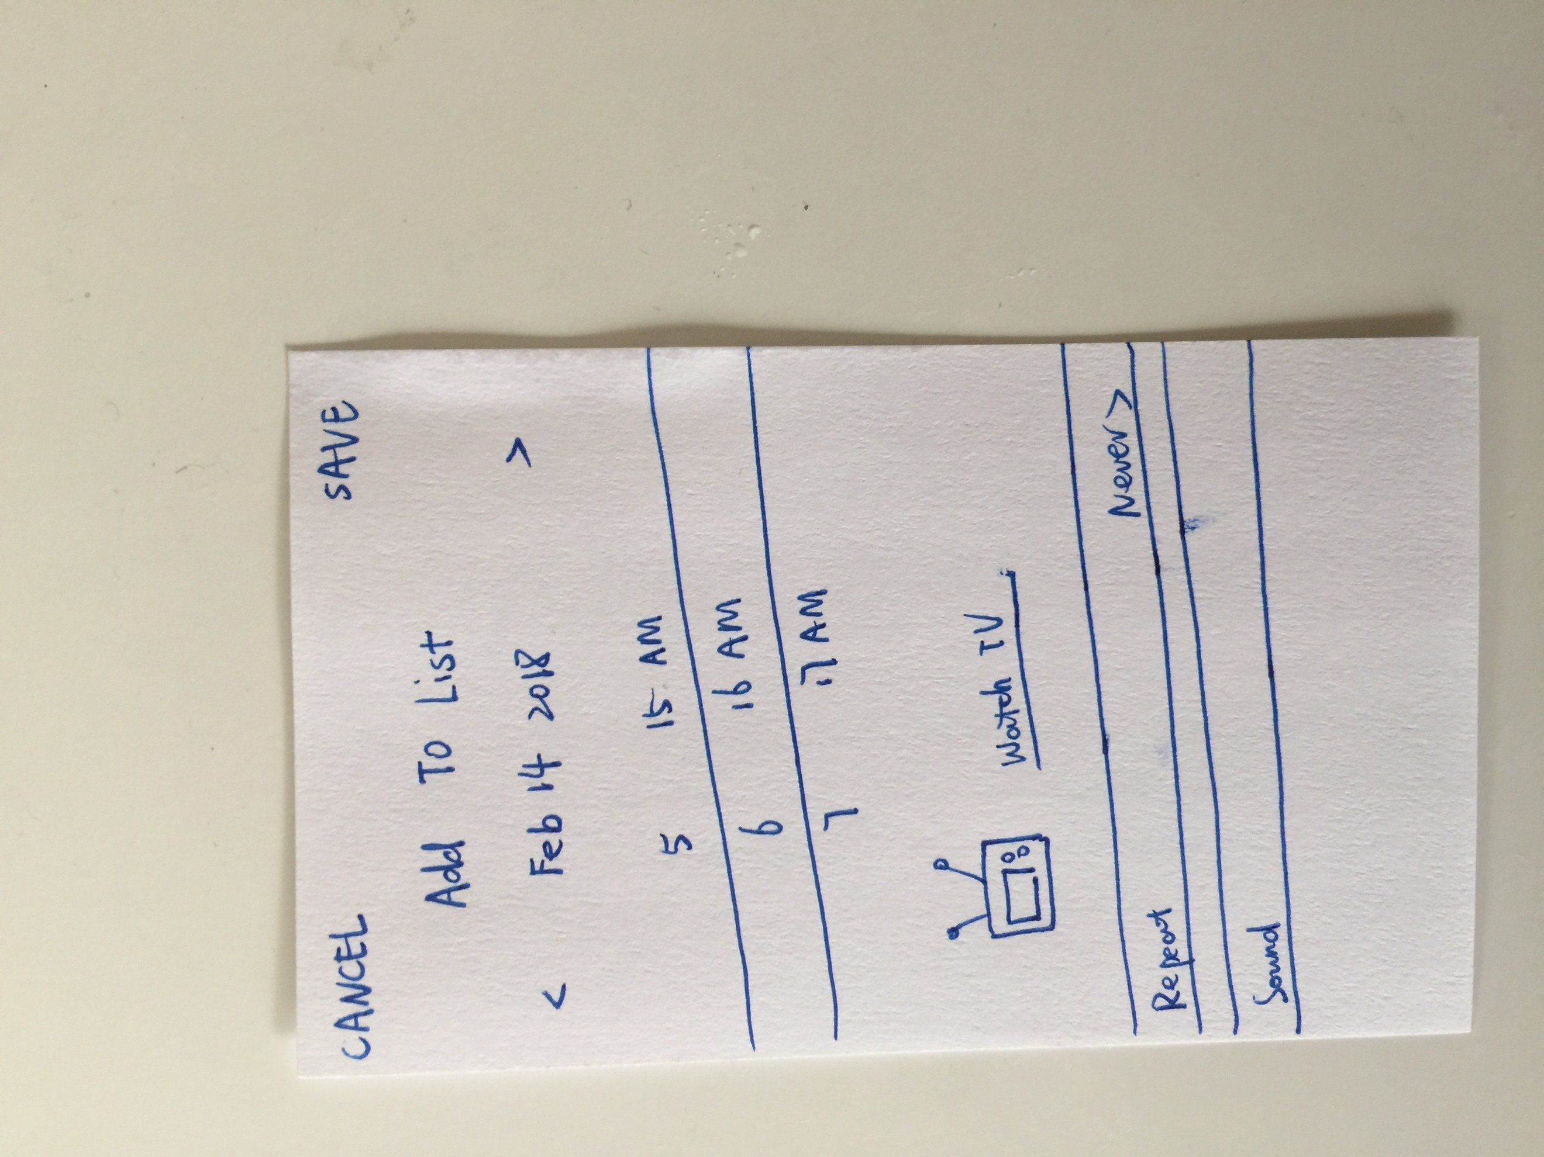**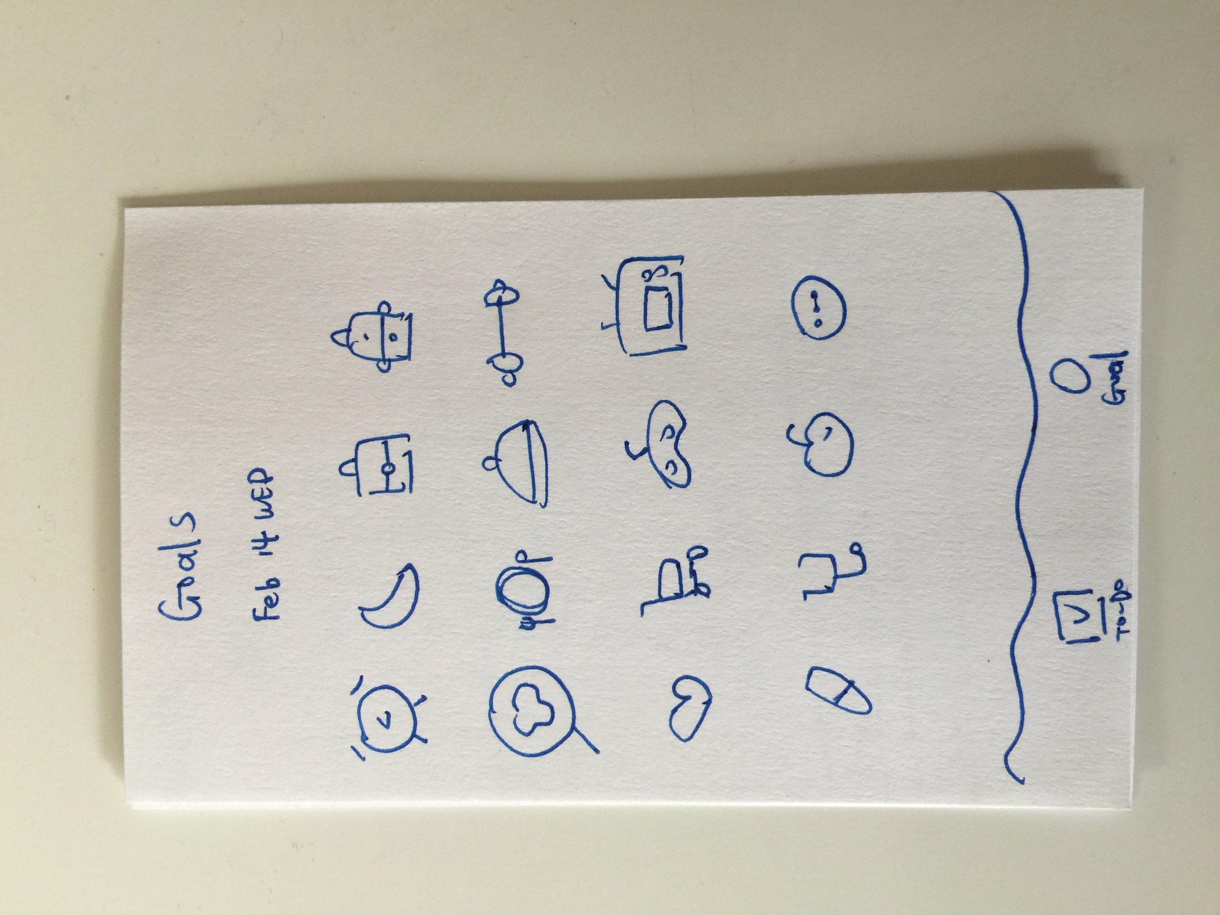Prototype:**

*Note that functions will vary depends on how much I can achieve and this is the very basic function.